UNITED STATES
SECURITIES AND EXCHANGE COMMISSION
Washington, D.C. 20549
FORM 8-K
CURRENT REPORT
Pursuant to Section 13 or 15(d) of the Securities Exchange Act of 1934
Date of Report (Date of earliest event reported): May 11, 2026

ATYR PHARMA, INC.
(Exact name of registrant as specified in its charter)

Delaware |  | 001-37378 |  | 20-3435077
(State or other jurisdiction  of incorporation) |  | (Commission File Number) |  | (IRS Employer  Identification No.)
10240 Sorrento Valley Road, Suite 300  San Diego, CA |  |  |  | 92121
(Address of Principal Executive Offices) |  |  |  | (Zip Code)
Registrant’s telephone number, including area code: (858) 731-8389
Not Applicable
(Former Name or Former Address, if Changed Since Last Report)

Check the appropriate box below if the Form 8-K filing is intended to simultaneously satisfy the filing obligation of the registrant under any of the following provisions:
☐ | Written communications pursuant to Rule 425 under the Securities Act (17 CFR 230.425)
☐ | Soliciting material pursuant to Rule 14a-12 under the Exchange Act (17 CFR 240.14a-12)
☐ | Pre-commencement communications pursuant to Rule 14d-2(b) under the Exchange Act (17 CFR 240.14d-2(b))
☐ | Pre-commencement communications pursuant to Rule 13e-4(c) under the Exchange Act (17 CFR 240.13e-4(c))

Securities registered pursuant to Section 12(b) of the Act:

Title of each class | Trading Symbol(s) | Name of each exchange on which registered
Common Stock, par value $0.001 per share | ATYR | The Nasdaq Capital Market

Indicate by check mark whether the registrant is an emerging growth company as defined in Rule 405 of the Securities Act of 1933 or Rule 12b-2 of the Securities Exchange Act of 1934.
Emerging growth company ☐
If an emerging growth company, indicate by check mark if the registrant has elected not to use the extended transition period for complying with any new or revised financial accounting standards provided pursuant to Section 13(a) of the Exchange Act. ☐

Item 2.02 Results of Operations and Financial Condition.
As of March 31, 2026, aTyr Pharma, Inc. (the Company) had approximately $68.3 million of cash, cash equivalents, restricted cash and available-for-sale investments. This financial information is preliminary and unaudited, represents management’s estimate as of the date of this report, and does not present all necessary information for a complete understanding of the Company’s financial condition as of March 31, 2026. The actual financial results may differ materially from the preliminary estimated financial information.
Item 7.01 Regulation FD Disclosure.
On May 11, 2026, the Company made available a corporate presentation regarding a regulatory and clinical update with respect to the Company's continued development of efzofitimod in pulmonary sarcoidosis, a copy of which is attached hereto as Exhibit 99.1 and is incorporated herein by reference.
The information under Item 2.02 and this Item 7.01, including Exhibit 99.1, is being furnished and shall not be deemed “filed” for the purposes of Section 18 of the Securities Exchange Act of 1934, as amended (the Exchange Act) or otherwise subject to the liabilities of that section, nor shall it be deemed incorporated by reference into any other filing of the Company under the Securities Act of 1933, as amended, or the Exchange Act, whether made before or after the date hereof, regardless of any general incorporation language in such filing, except as expressly set forth by specific reference in such filing.
Item 8.01 Other Events.

On May 11, 2026, the Company announced a regulatory and clinical update for its lead therapeutic candidate, efzofitimod, in pulmonary sarcoidosis, a major form of interstitial lung disease, following the receipt of the official meeting minutes from a Type C meeting with the U.S. Food and Drug Administration (FDA).

The purpose of the meeting was to review the results of the Phase 3 EFZO-FIT study and determine the next steps for the program in pulmonary sarcoidosis. Based on feedback from the FDA, the Company plans to continue the development of efzofitimod in pulmonary sarcoidosis in a new Phase 3 study in patients with chronic, symptomatic pulmonary sarcoidosis with restrictive lung disease utilizing forced vital capacity (FVC) as the primary endpoint of the study and the King’s Sarcoidosis Questionnaire (KSQ)-Lung score as the key secondary endpoint. The Company chose these endpoints based on the FDA’s indication that FVC and KSQ-Lung are direct measures of how patients suffering from pulmonary sarcoidosis function and feel, and the Company concluded FVC to be a more appropriate primary endpoint at this time pending further content validation work for the KSQ-Lung as recommended by the FDA. The Company determined the patient population for the study, those with restrictive lung disease, based on data from the EFZO-FITTM study which included 44 patients with restrictive lung disease (defined as FVC percent predicted ≤ 80%) and showed a difference of 124 ml in change from baseline in FVC between restrictive patients treated with 5.0 mg/kg efzofitimod and placebo.

As part of the Company’s discussion with the FDA regarding the benefit risk profile for efzofitimod, the Company plans to increase the frequency of dosing of 5.0 mg/kg efzofitimod or placebo from once every four weeks in past trials to once every three weeks in this next trial. The Company is choosing the dosing regimen based on the FDA’s acknowledgment of its reasonableness from a clinical pharmacology perspective, subject to inclusion of adequate safety monitoring and risk mitigation procedures. The Company plans to include additional risk mitigation strategies, enhanced safety surveillance for the potential development of anti-synthetase syndrome and a data safety monitoring committee. The Company plans to submit an investigational new drug (IND) application for this study in June 2026.

The Phase 3 trial is expected to be a global, randomized, double-blind, placebo-controlled study to evaluate the efficacy and safety of efzofitimod in patients with moderate to severe pulmonary sarcoidosis. The 54-week study will consist of two parallel cohorts randomized equally to either 5.0 mg/kg efzofitimod or placebo dosed intravenously once every 3 weeks for a total of 17 doses. The study is intended to enroll up to approximately 372 patients with symptomatic pulmonary sarcoidosis with restrictive lung disease who are receiving a stable dose of ≤ 5.0 mg daily oral corticosteroid and/or a background immunosuppressant. All background treatment will remain stable throughout the duration of the study. The primary endpoint of the study will be change

2

from baseline in FVC at week 48 and the key secondary endpoint will be change from baseline in the KSQ-Lung score at week 48.

Forward-Looking Statements

This Current Report on Form 8-K (this “Current Report”) contains forward-looking statements within the meaning of the Private Securities Litigation Reform Act of 1995. Words such as “continue,” “expected,” “intended,” “plans,” “will,” and similar expressions (as well as other words or expressions referencing future events, conditions or circumstances) are intended to identify forward-looking statements. These forward-looking statements are based on the Company’s expectations and assumptions as of the date of this Current Report. Each of these forward-looking statements involves risks and uncertainties. Actual results may differ materially from these forward-looking statements. Forward-looking statements contained in this Current Report include, but are not limited to, statements regarding the Company’s financial condition as of March 31, 2026 expected to be reported in its Quarterly Report on Form 10-Q for the period ended March 31, 2026, continued development of efzofitimod in pulmonary sarcoidosis, the potential therapeutic benefits and applications of efzofitimod, the Company’s timelines and plans with respect to certain development activities and goals, including the submission (and planned timing of submission) of an IND for a Phase 3 study of efzofitimod in pulmonary sarcoidosis in June 2026, the proposed design of the Company’s planned Phase 3 study of efzofitimod in pulmonary sarcoidosis, including the dosing regimen, enrollment expectations, targeted endpoints, strategy to focus on a more limited patient population and strategy to mitigate additional safety concerns, and the Company’s interpretation of the results of the Phase 3 EFZO-FITTM study and the meaning of those interpretations for the Company’s planned Phase 3 study. Many factors may cause differences between current expectations and actual results, including, but not limited to, uncertainty related to interactions with the FDA in general, uncertainty regarding geopolitical and macroeconomic events, risks associated with the discovery, development and regulation of efzofitimod, the risks associated with targeting a more limited patient population in the Company’s planned Phase 3 study of efzofitimod in pulmonary sarcoidosis, the risk that the Company or its partners may cease or delay preclinical or clinical development activities for efzofitimod for a variety of reasons (including difficulties or delays in patient enrollment in planned clinical trials), the possibility that existing collaborations could be terminated early, and the risk that the Company may not be able to raise the additional funding required for its business and product development plans. Other factors that may cause actual results to differ from those expressed or implied in the forward-looking statements in this Current Report are discussed in the Company’s filings with the Securities and Exchange Commission, including its Annual Report on Form 10-K, Quarterly Reports on Form 10-Q and Current Reports on Form 8-K. Except as required by law, the Company assumes no obligation to update any forward-looking statements contained herein to reflect any change in expectations, even as new information becomes available.
Item 9.01 Financial Statements and Exhibits.
(d) Exhibits

Exhibit No. |  | Description
99.1 |  | Corporate Presentation Materials of aTyr Pharma, Inc. dated May 11, 2026
104 |  | Cover Page Interactive Data File (embedded within the Inline XBRL document)

3

SIGNATURE
Pursuant to the requirements of the Securities Exchange Act of 1934, the registrant has duly caused this report to be signed on its behalf by the undersigned hereunto duly authorized.
 | ATYR PHARMA, INC.
 | By: | /s/ Jill M. Broadfoot
 |  | Jill M. Broadfoot
 |  | Chief Financial Officer
Date: May 11, 2026

4

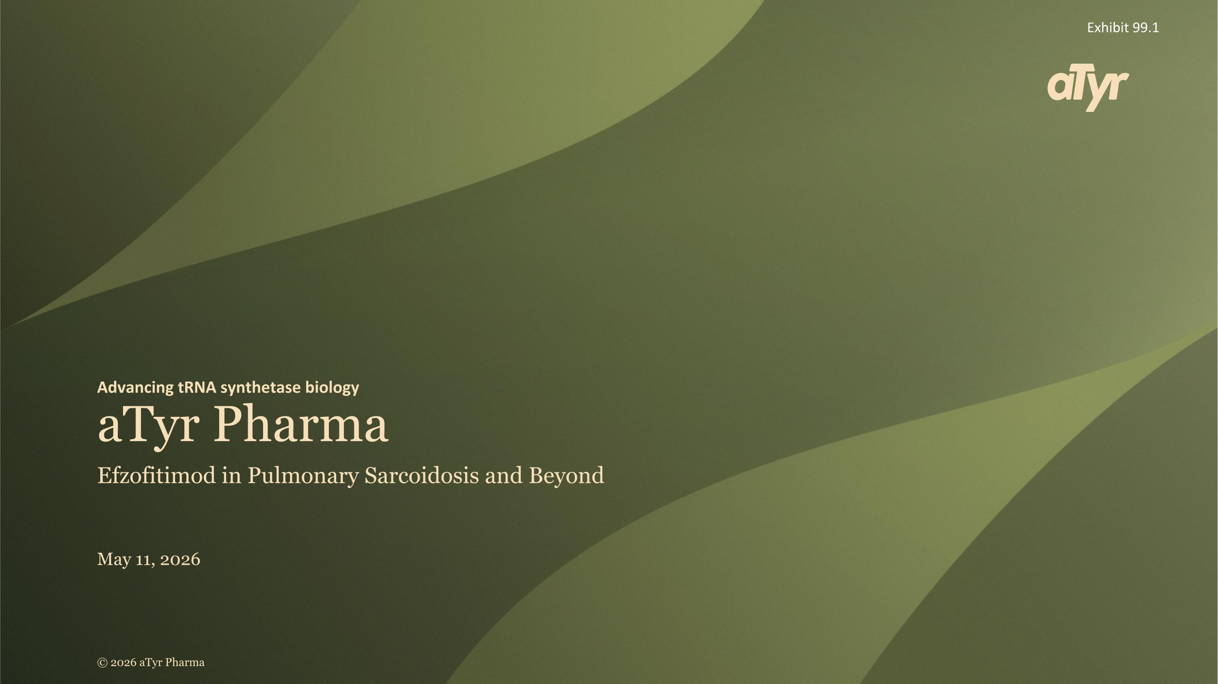
aTyr Pharma Advancing tRNA synthetase biology Efzofitimod in Pulmonary Sarcoidosis and Beyond May 11, 2026 © 2026 aTyr Pharma Exhibit 99.1

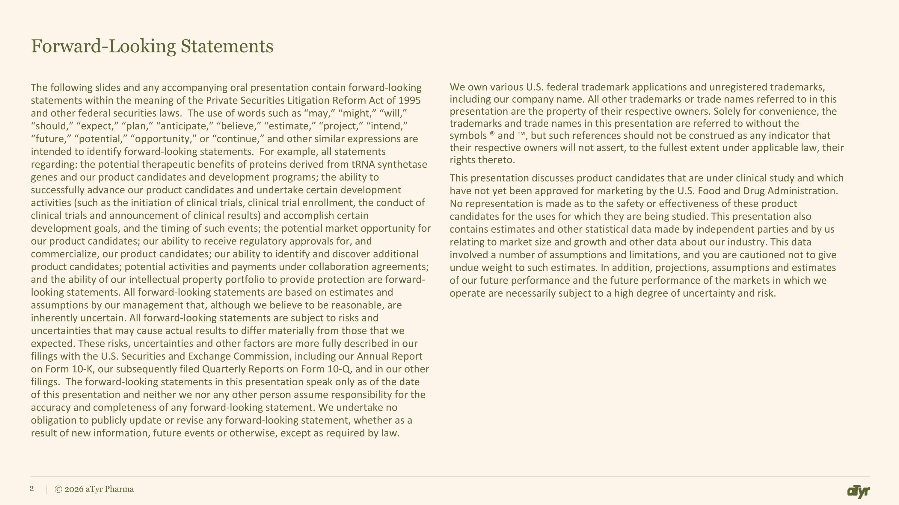
Forward-Looking Statements The following slides and any accompanying oral presentation contain forward-looking statements within the meaning of the Private Securities Litigation Reform Act of 1995 and other federal securities laws. The use of words such as “may,” “might,” “will,” “should,” “expect,” “plan,” “anticipate,” “believe,” “estimate,” “project,” “intend,” “future,” “potential,” “opportunity,” or “continue,” and other similar expressions are intended to identify forward-looking statements. For example, all statements regarding: the potential therapeutic benefits of proteins derived from tRNA synthetase genes and our product candidates and development programs; the ability to successfully advance our product candidates and undertake certain development activities (such as the initiation of clinical trials, clinical trial enrollment, the conduct of clinical trials and announcement of clinical results) and accomplish certain development goals, and the timing of such events; the potential market opportunity for our product candidates; our ability to receive regulatory approvals for, and commercialize, our product candidates; our ability to identify and discover additional product candidates; potential activities and payments under collaboration agreements; and the ability of our intellectual property portfolio to provide protection are forward-looking statements. All forward-looking statements are based on estimates and assumptions by our management that, although we believe to be reasonable, are inherently uncertain. All forward-looking statements are subject to risks and uncertainties that may cause actual results to differ materially from those that we expected. These risks, uncertainties and other factors are more fully described in our filings with the U.S. Securities and Exchange Commission, including our Annual Report on Form 10-K, our subsequently filed Quarterly Reports on Form 10-Q, and in our other filings. The forward-looking statements in this presentation speak only as of the date of this presentation and neither we nor any other person assume responsibility for the accuracy and completeness of any forward-looking statement. We undertake no obligation to publicly update or revise any forward-looking statement, whether as a result of new information, future events or otherwise, except as required by law. We own various U.S. federal trademark applications and unregistered trademarks, including our company name. All other trademarks or trade names referred to in this presentation are the property of their respective owners. Solely for convenience, the trademarks and trade names in this presentation are referred to without the symbols ® and , but such references should not be construed as any indicator that their respective owners will not assert, to the fullest extent under applicable law, their rights thereto. This presentation discusses product candidates that are under clinical study and which have not yet been approved for marketing by the U.S. Food and Drug Administration. No representation is made as to the safety or effectiveness of these product candidates for the uses for which they are being studied. This presentation also contains estimates and other statistical data made by independent parties and by us relating to market size and growth and other data about our industry. This data involved a number of assumptions and limitations, and you are cautioned not to give undue weight to such estimates. In addition, projections, assumptions and estimates of our future performance and the future performance of the markets in which we operate are necessarily subject to a high degree of uncertainty and risk. | © 2026 aTyr Pharma

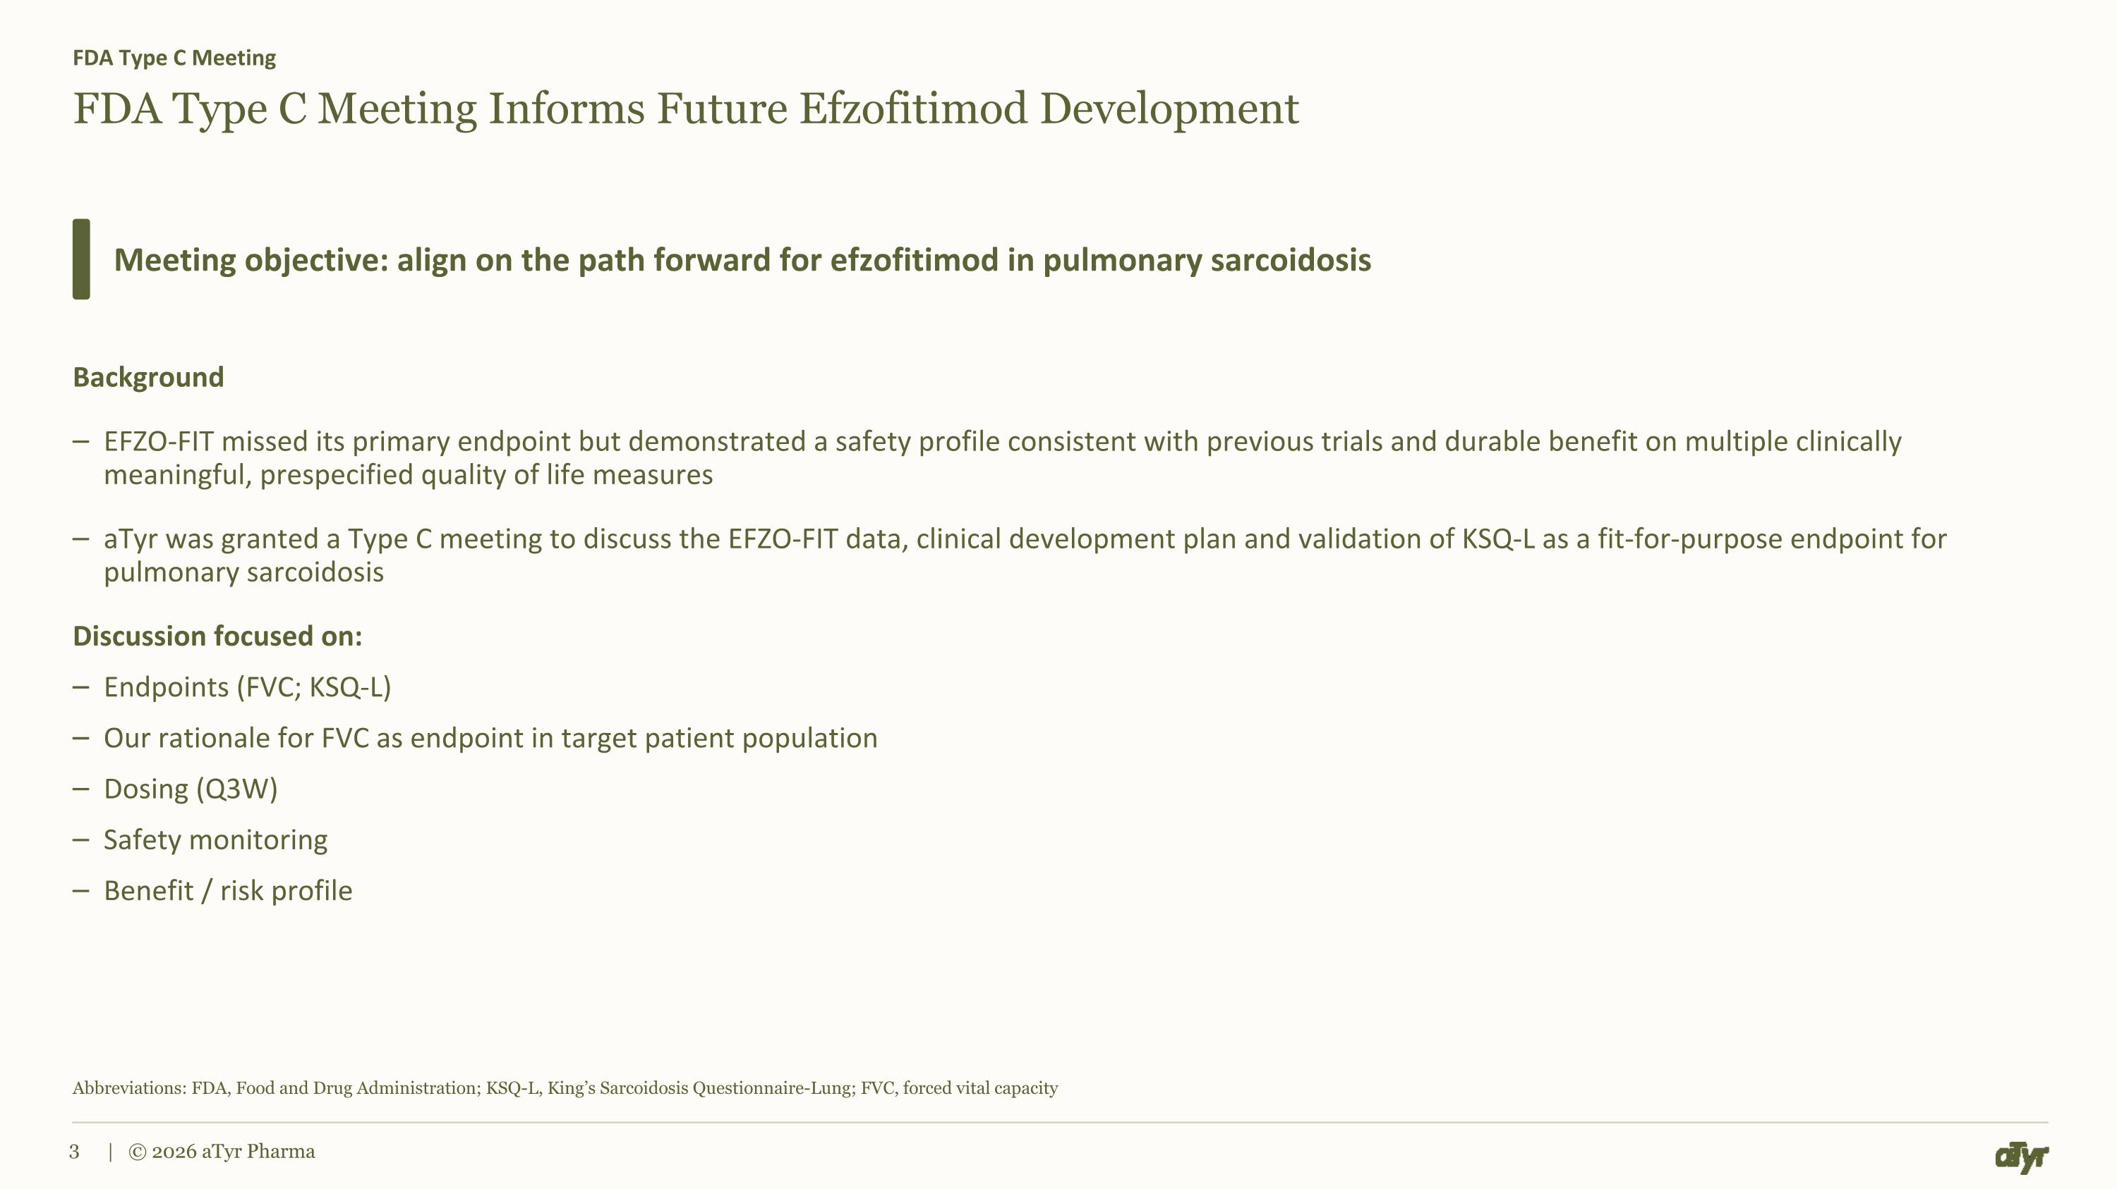
FDA Type C Meeting Informs Future Efzofitimod Development Background EFZO-FIT missed its primary endpoint but demonstrated a safety profile consistent with previous trials and durable benefit on multiple clinically meaningful, prespecified quality of life measures aTyr was granted a Type C meeting to discuss the EFZO-FIT data, clinical development plan and validation of KSQ-L as a fit-for-purpose endpoint for pulmonary sarcoidosis Discussion focused on: Endpoints (FVC; KSQ-L) Our rationale for FVC as endpoint in target patient population Dosing (Q3W) Safety monitoring Benefit / risk profile FDA Type C Meeting Meeting objective: align on the path forward for efzofitimod in pulmonary sarcoidosis Abbreviations: FDA, Food and Drug Administration; KSQ-L, King’s Sarcoidosis Questionnaire-Lung; FVC, forced vital capacity | © 2026 aTyr Pharma

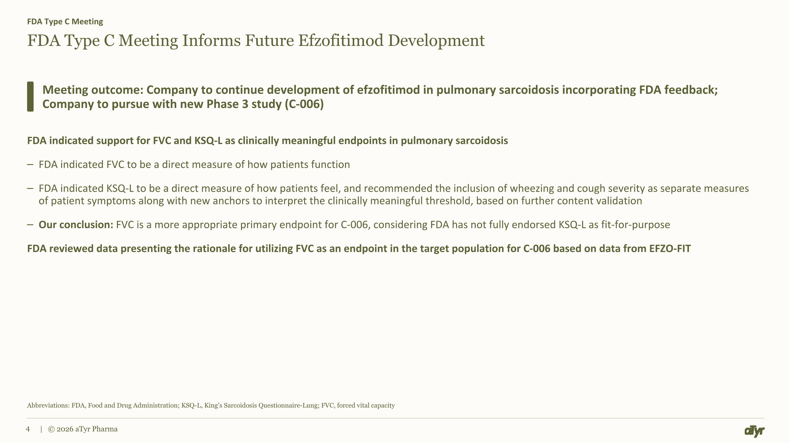
FDA Type C Meeting Informs Future Efzofitimod Development FDA indicated support for FVC and KSQ-L as clinically meaningful endpoints in pulmonary sarcoidosis FDA indicated FVC to be a direct measure of how patients function FDA indicated KSQ-L to be a direct measure of how patients feel, and recommended the inclusion of wheezing and cough severity as separate measures of patient symptoms along with new anchors to interpret the clinically meaningful threshold, based on further content validation Our conclusion: FVC is a more appropriate primary endpoint for C-006, considering FDA has not fully endorsed KSQ-L as fit-for-purpose FDA reviewed data presenting the rationale for utilizing FVC as an endpoint in the target population for C-006 based on data from EFZO-FIT FDA Type C Meeting Meeting outcome: Company to continue development of efzofitimod in pulmonary sarcoidosis incorporating FDA feedback; Company to pursue with new Phase 3 study (C-006) Abbreviations: FDA, Food and Drug Administration; KSQ-L, King’s Sarcoidosis Questionnaire-Lung; FVC, forced vital capacity | © 2026 aTyr Pharma

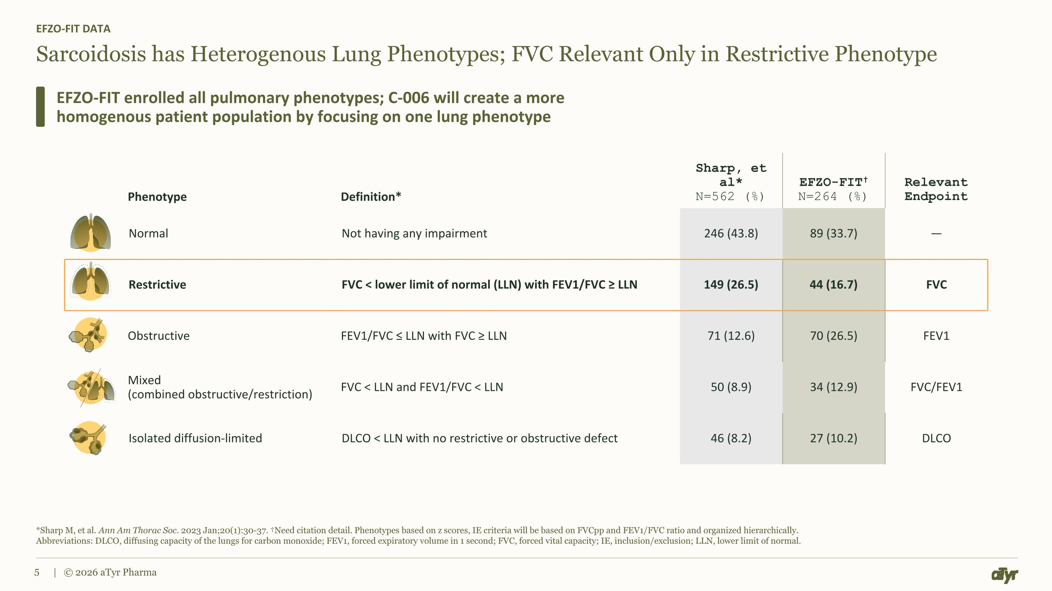
Sarcoidosis has Heterogenous Lung Phenotypes; FVC Relevant Only in Restrictive Phenotype EFZO-FIT DATA EFZO-FIT enrolled all pulmonary phenotypes; C-006 will create a more homogenous patient population by focusing on one lung phenotype *Sharp M, et al. Ann Am Thorac Soc. 2023 Jan;20(1):30-37. Need citation detail. Phenotypes based on z scores, IE criteria will be based on FVCpp and FEV1/FVC ratio and organized hierarchically. Abbreviations: DLCO, diffusing capacity of the lungs for carbon monoxide; FEV1, forced expiratory volume in 1 second; FVC, forced vital capacity; IE, inclusion/exclusion; LLN, lower limit of normal. | © 2026 aTyr Pharma Phenotype Definition* Sharp, et al* N=562 (%) EFZO-FIT?N=264 (%) Relevant Endpoint Normal Not having any impairment 246 (43.8) 89 (33.7) — Restrictive FVC < lower limit of normal (LLN) with FEV1/FVC ≥ LLN 149 (26.5) 44 (16.7) FVC Obstructive FEV1/FVC ≤ LLN with FVC ≥ LLN 71 (12.6) 70 (26.5) FEV1 Mixed?(combined obstructive/restriction) FVC < LLN and FEV1/FVC < LLN 50 (8.9) 34 (12.9) FVC/FEV1 Isolated diffusion-limited DLCO < LLN with no restrictive or obstructive defect 46 (8.2) 27 (10.2) DLCO

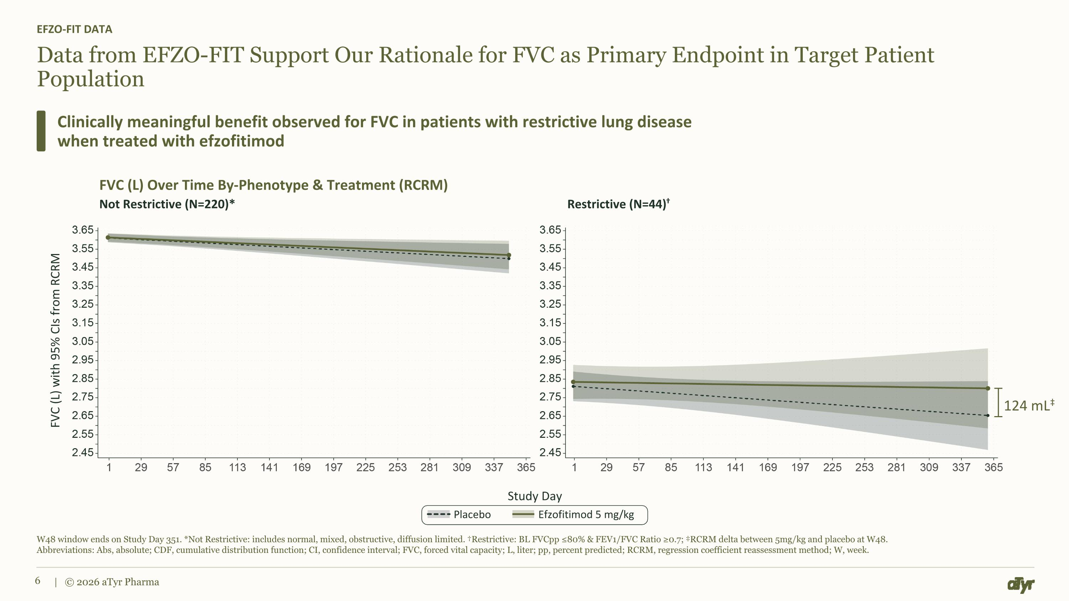
Data from EFZO-FIT Support Our Rationale for FVC as Primary Endpoint in Target Patient Population EFZO-FIT DATA Clinically meaningful benefit observed for FVC in patients with restrictive lung disease when treated with efzofitimod W48 window ends on Study Day 351. *Not Restrictive: includes normal, mixed, obstructive, diffusion limited. Restrictive: BL FVCpp ≤80% & FEV1/FVC Ratio ≥0.7; RCRM delta between 5mg/kg and placebo at W48. Abbreviations: Abs, absolute; CDF, cumulative distribution function; CI, confidence interval; FVC, forced vital capacity; L, liter; pp, percent predicted; RCRM, regression coefficient reassessment method; W, week. | © 2026 aTyr Pharma FVC (L) with 95% CIs from RCRM Study Day FVC (L) Over Time By-Phenotype & Treatment (RCRM) Not Restrictive (N=220)* Restrictive (N=44) Placebo Efzofitimod 5 mg/kg 124 mL

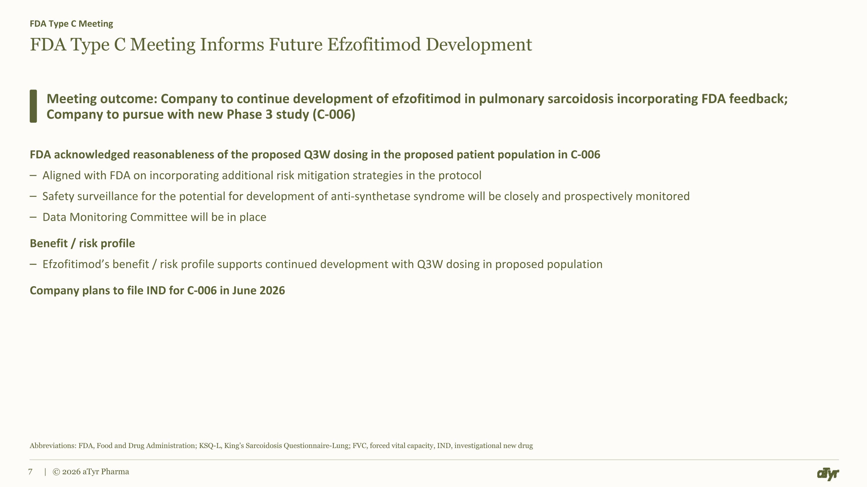
FDA Type C Meeting Informs Future Efzofitimod Development FDA acknowledged reasonableness of the proposed Q3W dosing in the proposed patient population in C-006 Aligned with FDA on incorporating additional risk mitigation strategies in the protocol Safety surveillance for the potential for development of anti-synthetase syndrome will be closely and prospectively monitored Data Monitoring Committee will be in place Benefit / risk profile Efzofitimod’s benefit / risk profile supports continued development with Q3W dosing in proposed population Company plans to file IND for C-006 in June 2026 FDA Type C Meeting Meeting outcome: Company to continue development of efzofitimod in pulmonary sarcoidosis incorporating FDA feedback; Company to pursue with new Phase 3 study (C-006) Abbreviations: FDA, Food and Drug Administration; KSQ-L, King’s Sarcoidosis Questionnaire-Lung; FVC, forced vital capacity, IND, investigational new drug | © 2026 aTyr Pharma

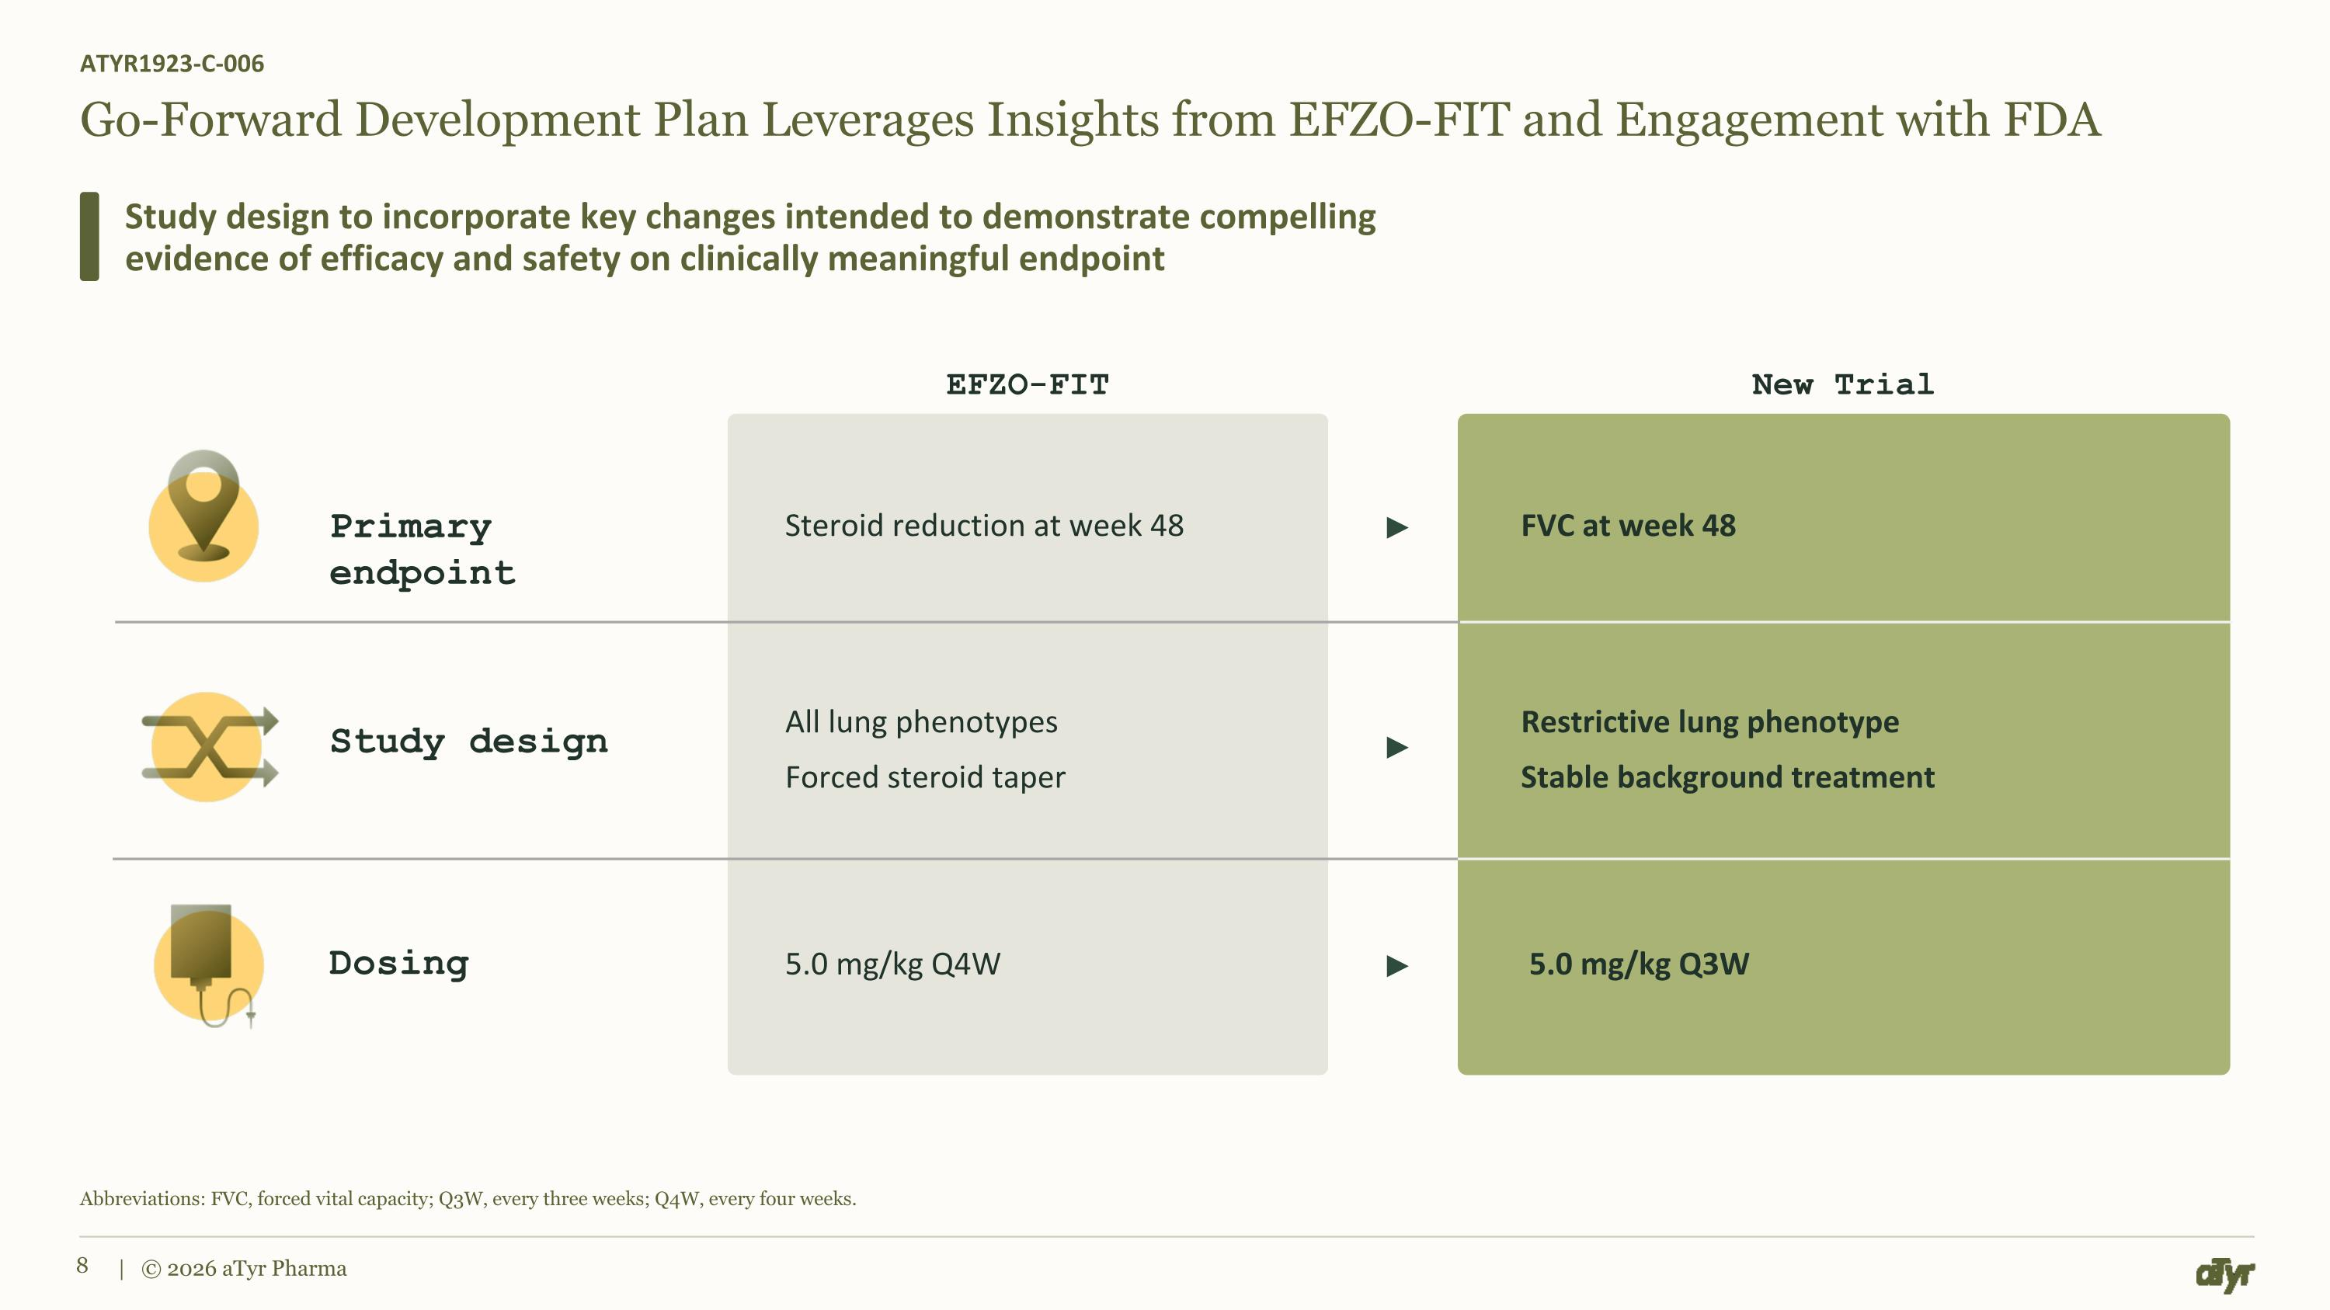
Go-Forward Development Plan Leverages Insights from EFZO-FIT and Engagement with FDA ATYR1923-C-006 Study design to incorporate key changes intended to demonstrate compelling evidence of efficacy and safety on clinically meaningful endpoint Abbreviations: FVC, forced vital capacity; Q3W, every three weeks; Q4W, every four weeks. | © 2026 aTyr Pharma All lung phenotypes Forced steroid taper 5.0 mg/kg Q4W Steroid reduction at week 48 Study design Primary endpoint Dosing Restrictive lung phenotype Stable background treatment FVC at week 48 5.0 mg/kg Q3W EFZO-FIT New Trial

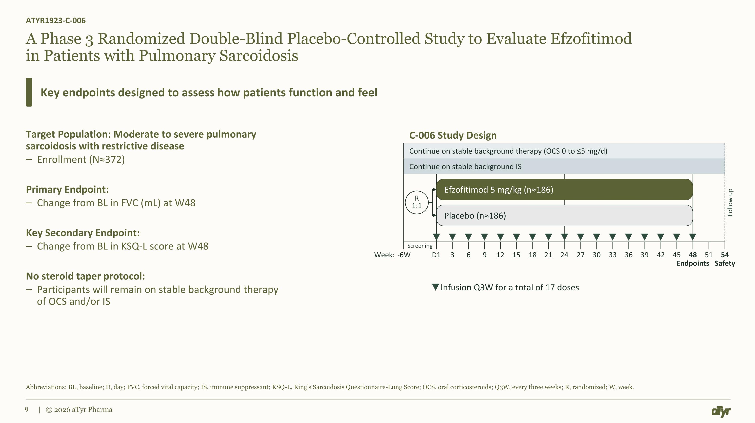
Continue on stable background therapy (OCS 0 to ≤5 mg/d) Continue on stable background IS Screening A Phase 3 Randomized Double-Blind Placebo-Controlled Study to Evaluate Efzofitimod in Patients with Pulmonary Sarcoidosis Target Population: Moderate to severe pulmonary sarcoidosis with restrictive disease Enrollment (N≈372) Primary Endpoint: Change from BL in FVC (mL) at W48 Key Secondary Endpoint: Change from BL in KSQ-L score at W48 No steroid taper protocol: Participants will remain on stable background therapy of OCS and/or IS ATYR1923-C-006 Key endpoints designed to assess how patients function and feel Abbreviations: BL, baseline; D, day; FVC, forced vital capacity; IS, immune suppressant; KSQ-L, King’s Sarcoidosis Questionnaire-Lung Score; OCS, oral corticosteroids; Q3W, every three weeks; R, randomized; W, week. | © 2026 aTyr Pharma Efzofitimod 5 mg/kg (n≈186) Placebo (n≈186) R?1:1 Follow up Infusion Q3W for a total of 17 doses -6W 6 9 12 15 18 21 24 27 30 33 48 Endpoints 54 Safety D1 Week: 3 36 39 42 45 51 C-006 Study Design

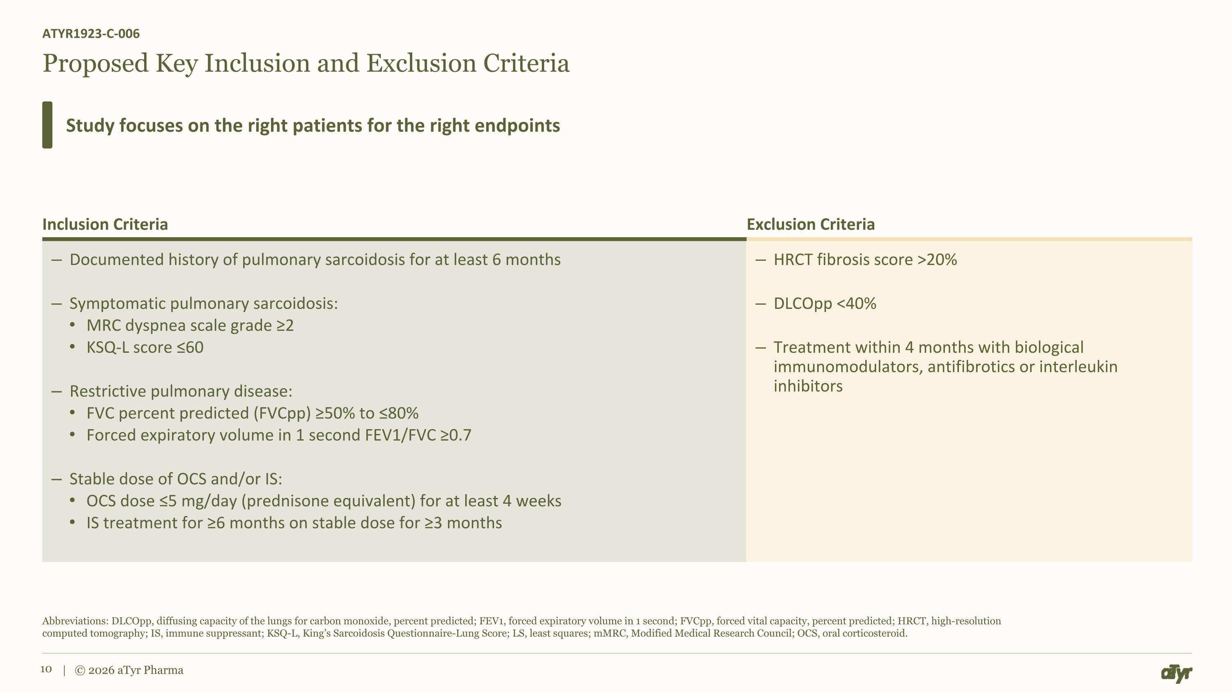
Proposed Key Inclusion and Exclusion Criteria ATYR1923-C-006 Study focuses on the right patients for the right endpoints Abbreviations: DLCOpp, diffusing capacity of the lungs for carbon monoxide, percent predicted; FEV1, forced expiratory volume in 1 second; FVCpp, forced vital capacity, percent predicted; HRCT, high-resolution ?computed tomography; IS, immune suppressant; KSQ-L, King’s Sarcoidosis Questionnaire-Lung Score; LS, least squares; mMRC, Modified Medical Research Council; OCS, oral corticosteroid. | © 2026 aTyr Pharma Inclusion Criteria Exclusion Criteria Documented history of pulmonary sarcoidosis for at least 6 months Symptomatic pulmonary sarcoidosis: MRC dyspnea scale grade ≥2 KSQ-L score ≤60 Restrictive pulmonary disease: FVC percent predicted (FVCpp) ≥50% to ≤80% Forced expiratory volume in 1 second FEV1/FVC ≥0.7 Stable dose of OCS and/or IS: OCS dose ≤5 mg/day (prednisone equivalent) for at least 4 weeks IS treatment for ≥6 months on stable dose for ≥3 months HRCT fibrosis score >20% DLCOpp <40% Treatment within 4 months with biological immunomodulators, antifibrotics or interleukin inhibitors

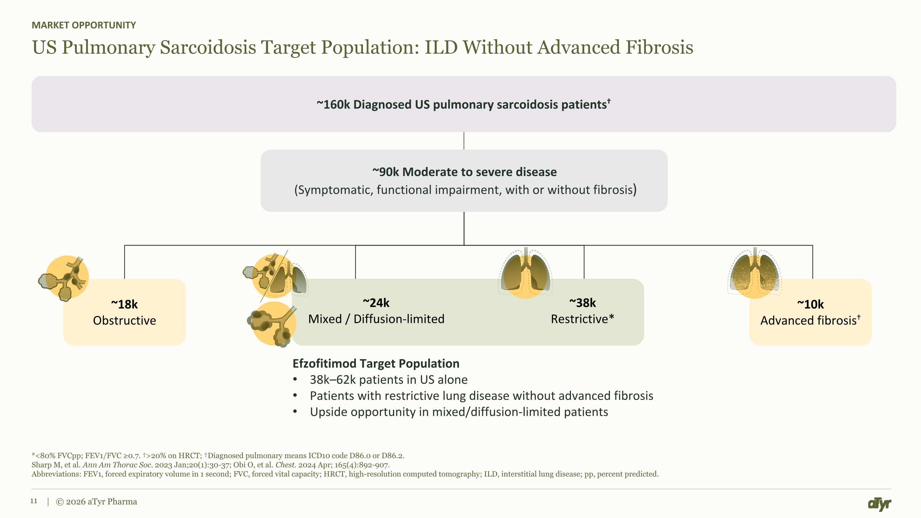
*<80% FVCpp; FEV1/FVC ≥0.7. >20% on HRCT; Diagnosed pulmonary means ICD10 code D86.0 or D86.2. Sharp M, et al. Ann Am Thorac Soc. 2023 Jan;20(1):30-37; Obi O, et al. Chest. 2024 Apr; 165(4):892-907. Abbreviations: FEV1, forced expiratory volume in 1 second; FVC, forced vital capacity; HRCT, high-resolution computed tomography; ILD, interstitial lung disease; pp, percent predicted. | © 2026 aTyr Pharma US Pulmonary Sarcoidosis Target Population: ILD Without Advanced Fibrosis MARKET OPPORTUNITY ~160k Diagnosed US pulmonary sarcoidosis patients ~90k Moderate to severe disease (Symptomatic, functional impairment, with or without fibrosis) Efzofitimod Target Population 38k–62k patients in US alone Patients with restrictive lung disease without advanced fibrosis Upside opportunity in mixed/diffusion-limited patients ~18k Obstructive ~24k Mixed / Diffusion-limited ~38k Restrictive* ~10k Advanced fibrosis


| © 2026 aTyr Pharma Thank You

